**Collaborative Conservation Skills Internship Programme**

Host Application Form

*Please complete and return this form to* [*accreditation@icon.org.uk*](mailto:accreditation@icon.org.uk) *by 6 May 2025 at 9am. If you have any questions, please don’t hesitate to get in touch via email on the above address.*

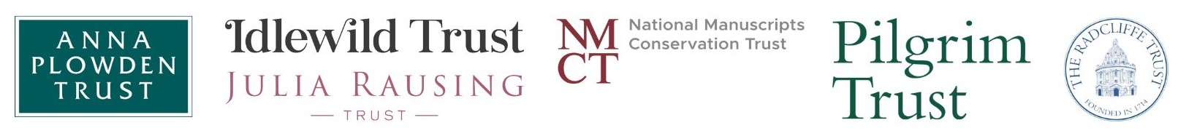

**Applicant details**

|  |  |
| --- | --- |
| **Name** |  |
| **Job Title** |  |
| **Organisation** |  |
| **Address** |  |
| **Email** |  |
| **Phone Number** |  |

**About your organisation**

|  |
| --- |
| **Please provide a brief outline of your organisation, including the nature of your collections.**  *No more than 200 words* |
|  |

|  |
| --- |
| **Please provide a brief outline of your conservation workforce, including key staff members that the internship will be supported by during the internship.**  *No more than 200 words* |
|  |

|  |  |
| --- | --- |
| **Name of supervisor** |  |
| **Status** | Icon Accredited / Pathway Member / Other Accreditation / None |

**Overview of internship opportunity**

|  |  |
| --- | --- |
| **Material Specialism** | Musical Instruments / Manuscripts |

|  |
| --- |
| **Please outline the specific opportunity that you are able to offer the intern, including the specific projects that the intern would be able to work on during their internship.**  *No more than 300 words* |
|  |

**Management model**

*There are two funding models which have been agreed upon. The model chosen is at the discretion of the host organisation.*

|  |  |
| --- | --- |
| **Management** | Self-managed / Icon-managed |

**Declaration**

|  |  |
| --- | --- |
| **Name** |  |
| **Job Title** |  |
| **Date** |  |