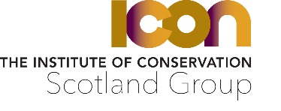
APPLICATION FOR SCOTLAND GROUP ACCREDITATION GRANT
Name……………………………………………………………………………………………………………………….
Address…………………………………………………………………………………………………………………….
…………………………………………………………………………………………………………………………………
Postcode……………………………….. Email……………………………………………………………………..
Employer name/job status………………………………………………………………………………………
Conservation discipline ………………………………… ……………………………………………………….
Date when you intend to submit or have already submitted your application…………………
Are you receiving any other contributions towards the fee? Yes/No
If yes, please give details including the amount you will receive……………………………………..…
…………………………………………………………………………………………………………………………….....
In no more than 250 words, please detail the ways in which you believe PACR status will contribute to your career development.

Declaration
- I herewith confirm that I am applying for PACR accreditation and that this grant will be used solely towards accreditation process costs
- I am a full member of the Institute of Conservation and have chosen Scotland Group as one of my groups
- Should my Scotland Group accreditation grant application be successful, I agree to provide a copy of my accreditation award letter to the Scotland Group

Signature……………………………………………….. Date ……………………………….
Return to the Vice-Chair of the Icon Scotland Group: igriffin@nationalgalleries.org with “ISG Accreditation Grant Application - Confidential” in the subject line. Preference will be given to grant applications received at least one month before the accreditation application deadline, although where funds permit applications received up to one month after an accreditation application was submitted will still be considered.

